To give all children the exposure to a variety of physical activities both indoors and outdoors every week. With an aim to support every child in developing an understanding of how to live a healthy lifestyle and the importance of keeping active. We also strive to give children the opportunity to compete in sporting events to spark the passion for sport.

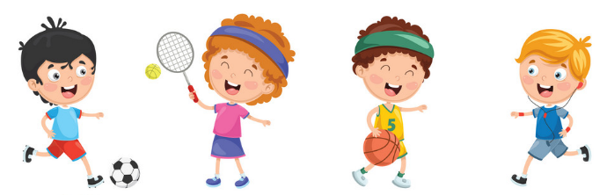

A LOVE for sporting activities to keep us fit and healthy

RESPECT our team mates, the rules and our opponents

Show COURAGE when taking on new sporting challenges

To follow the BOUNDARIES given in sport

To be RESILIENT if I struggle first time

To be FOCUSED on the task in hand

To give RESPECT to my team mates, the rules and my opponents

To SELF-REGULATE if things do not go to plan

To be Independent and accept responsibility for my actions

Intent:

At St John’s C of E Primary School, we aim to develop pupils who will be physically active and promote key attributes such as resilience, focus, courage and respect by putting the Physical education programmes of study: key stages 1 and 2, so that pupils’ flourish in a range of different physical activities.

The aims of our PE curriculum are to develop pupils who:

* Are willing to practice skills in a range of different activities and situations, alone, in small groups and in teams, and to apply these skills in chosen activities to achieve exceptionally high levels of performance;
* Have and maintain high levels of physical fitness;
* Lead a healthy lifestyle which is achieved by eating sensibly, being aware of the dangers of drugs, smoking and alcohol and exercising regularly;
* Are able to remain physically active for sustained periods of time and have an understanding of the importance of this in promoting long-term health and well-being;
* Take the initiative and become excellent young leaders, organising and officiating, and evaluating what needs to be done to improve, and motivating and instilling excellent sporting attitudes in others;
* Employ imagination and creativity in their techniques, tactics and choreography;
* Are able to improve their own and others’ performance
* Have a keen interest in PE - a willingness to participate eagerly in every lesson, highly positive attitudes and the ability to make informed choices about engaging fully in extracurricular sport;
* Can swim at least 25 metres before the end of Year 6 and know how to remain safe in and around water

At St John’s C of E Primary school, we have developed an all-inclusive range of sporting opportunities, in school and in extra-curricular activities such as dance, football, gymnastics, basketball, archery and netball, that offer pupils a wide- variety of opportunities to access sports that they may not have access to outside of school time. The P.E curriculum at St John’s C of E School provides children with a relevant, coherent, progressive knowledge of the fundamental movement, skills and further links to health and well-being.

These are explored through our teaching of:

* Fundamental Movement Skills (FMS)
* Outdoor sports (football/ tennis/ basketball/ rounders/ cricket/ athletics/rugby)
* Indoor sports (dance/ gymnastics)
* Swimming
* Fitness

**Implementation:**

As part of the planning process, teachers plan the following:

* A cycle of lessons for each subject, which carefully plans for progression and depth;
* The use of regular formative and summative assessments are used to support learners’ ability to block learning and increase space in the working memory;
* Challenge questions for pupils to apply their learning in a philosophical/open manner;
* Opportunities to work with coaches in the field and learn from their work ethic and demonstrations of good practice.

**Impact:**

Our PE Curriculum is high quality, well thought out and is planned to demonstrate progression across the different year groups. If children are keeping up with the curriculum, they are deemed to be making good or better progress. Within lessons, there are opportunities for formative assessment that is ongoing throughout each lesson. It judges progress and enables the teacher to make flexible adaptations to their planned teaching. Through ongoing assessment, tasks are matched to the ability of each child through differentiated activities and adult support, thus providing a level of challenge that is stimulating for pupils.

In addition, we measure the impact of our curriculum through the following methods:

* A reflection on standards achieved against the planned outcomes;
* Pupil discussions/reflection about their learning;
* The annual tracking of standards across the curriculum;
* Assessments of pupils' achievements against the National Curriculum.